# CMPUT 307, 2022

Practice Final Exam, April 8, 2022

Discuss and Work Together in Groups of 4 on eClass

Last Name: ____________________________________

First Name: ____________________________________

Q1. (4 x 10 = 40 points) Circle ONE of the correct answers for each parts A-H & J.

1. The angle between the vectors (1,-2) and (2,0) is:
2. Arccos(√5) radians.
3. Arccos(1/√5) radians.
4. Arccos(1/5) radians.
5. Arccos(5) radians.
6. The cross product of the vectors (1,-2,0) and (0,-1,1) is:
7. (-2,-1,-1)
8. ~~(-1,-2,-1)~~
9. ~~(-1,-1,-2)~~
10. (-2,-1,-2)
11. The Normalized Sum of Squared Difference (NSSD) between two templates can be expressed as:
12. The distance between two vectors.
13. The cross product of two vectors.
14. ~~The inner product of two vectors.~~
15. ~~The angle between two vectors.~~
16. Let P1 be a point in homogeneous coordinate system. We apply a transform M1 to P1, and then apply another transform M2. Let the final location of the point is P2. This can be mathematically expressed as:
17. P2 = M1(M2P1)
18. P2 = M2(M1P1)
19. P1 = M1(M2P2)
20. P1 = M2(M1P2)
21. Which of the following components in PM can be used to compress images:
22. Distance to Mesh
23. Spring Energy
24. Scalar Component
25. ~~Discontinuity Curves~~

F. The co-variance matrix for the three points (4, 5), (6, 9) and (-1, -7) is:

~~(a) [ 26.00 60.00~~

~~60.00 138.67 ]~~

(b) [ 8.67 20.00

20.00 46.22 ]

(c) [ 6.50 15.00

15.00 34.67 ]

(d) [ 26.00 54.00

54.00 138.67 ]

G. Given a point p in dual quaternion representation, which of the following equation can be used to represent a rotation or translation of p:

1. p’ = q*pq* where q* = r + εt
2. p’ = q*p*q* where q* = r - εt*
3. p’ = q*p*q where q* = r* + εt*
4. p’ = qpq* where q* = r* - εt*

H. Which of the following statements is true for principal components analysis (PCA):

1. PCA is a statistical procedure that uses an orthogonal transformation to determine the principal components.
2. The number of principal components is greater than the number of original variables.
3. The transformation is defined in such a way that the first principal component has the lowest possible variance.
4. PCA converts a set of observations of possibly correlated variables into a set of uncorrelated variables.

I. A dual quaternion can model the movement of a solid object in 3D space. Select which statements are true:

1. ~~A dual quaternion is composed of two quaternion, one responsible for rotation and the other responsible for translation.~~
2. ~~Distances and angles between the points of the object are not preserved.~~
3. A limitation of Dual Quaternion skinning is that it has the bulging artifact problem.
4. A dual quaternion can represent a pure rotation just as a quaternion by setting the dual part to zero.

J. Which of the following statements is true?

1. Point Clouds are composed of vertices connected with edges and a Mesh is composed of discrete vertices.
2. A Mesh is composed of vertices connected with edges and Point Clouds are composed of vertices only.
3. A Mesh is generated by randomly adding edges between vertices.
4. More points mean worse quality for Point Clouds.

**Q2**. [25] Valence Driven Compression

Given 1000 vertices consider the following frequency table for different valences. For example, 10 vertices have valence 3, and another 10 vertices have valence 9.

1. Choose the frequency of valences 4 to 8. Select your own values, and do not copy values from notes.
2. What is the average bits/vertex needed to store the connectivity information in this case if we use the Valence Driven representation with Huffman Coding? (Show your derivations below.)

|  |  |
| --- | --- |
| **3** | **10** |
| **4** |  |
| **5** |  |
| **6** |  |
| **7** |  |
| **8** |  |
| **9** | 10 |

|  |  |  |  |  |  |  |
| --- | --- | --- | --- | --- | --- | --- |
| **sy** | **prob** |  |  |  |  |  |
|  |  |  |  |  |  |  |
|  |  |  |  |  |  |  |
|  |  |  |  |  |  |  |
|  |  |  |  |  |  |  |
|  |  |  |  |  |  |  |
|  |  |  |  |  |  |  |
|  |  |  |  |  |  |  |

**Q3**. [35] Consider the following grid for the triangle surface with vertices: {v1: (3, 3, z1), v2: (5, 3, z2), v3: (2, 2, z3), v4: (1, 4, z4), v5: (2, 5, z5), v6: (4, 5, z6), v7: (6, 4, z7), v8: (7, 3, z8), v9: (4, 1, z9)}, and faces: {v1v2v6, v1v2v9, v1v3v9, v1v3v4, v1v4v5, v1v5v6, v2v6v7, v2v7v8, v2v8v9}.

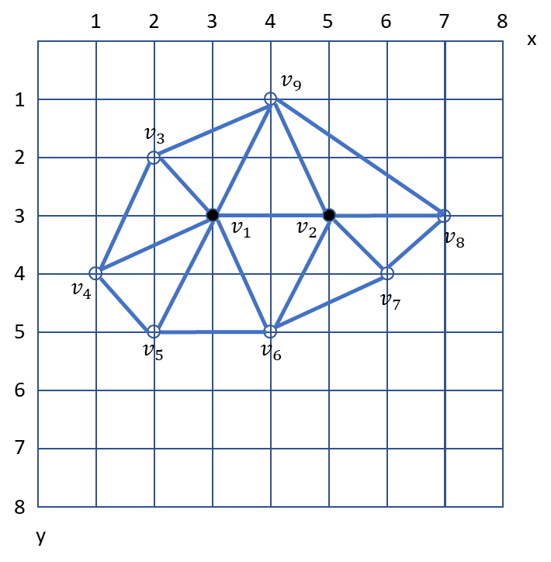

* 1. Choose 9 values for z1 to z9, so that these values are integers between 0 and 8, and no two values are the same. Do not discuss with others. The values for Z1 to z9 are expected to be mostly different for different students.
  2. Calculate the surface normal and the equations of all the 9 planes in the form ax+by+cz+d = 0. Use the notes related to calculating surface normal and equation of plane posted along with this exam.
  3. What are the Quadric Error Matrices for Vertex v1 and Vertex v2 at the beginning?
  4. What is the fundamental Quadric Error Matrix for collapsing Vertex v1 and Vertex v2?
  5. The QEM Metric at a vertex is supposed to represent each adjacent face (plane) exactly once. Is it possible to count a plane Multiple times in a Quadric during the simplification process? If so, explain how.
  6. Suggest an approach to ensure that a Quadric never counts a plane more than once during any stage of the simplification process.

Student #: ___________

|  |  |  |  |
| --- | --- | --- | --- |
| **#1** | **#2** | #3 | Total |
| /40 | /25 | /35 | /100 |